All Ireland Irish Angus YDP Showmanship Awards
All Ireland Supreme Champion & Overall Senior Female Champion
Name: DILLON VANCOUVER D.O.B. 05.09.22 Sire: LAVALLY PRINCE Dam: DILLON JANELLE Sire Of Dam: CONEYISLAND LEGEND Exhibitor: Niall & Brendan Regan, Gorthaganny, Castlerea, Co, Roscommon

All Ireland Reserve Supreme Champion & Overall Senior Male Champion
Name: GURTAVOHER VENICE D.O.B. 23.09.22 Sire: CLOONCARNE PELLET Dam: GURTAVOHER NAPLES Sire Of Dam: CASTLELOUGH MIDNIGHT BRANDY Exhibitor: John G Barlow, Gurtavoher West, Aherlow, Co. Tipperary
All Ireland Junior Supreme Champion & Overall Junior Male Champion
Name: DRUMHIRK WAGNER D.O.B. 24.10.23 Sire: TARA TERMINUS Dam: GLEANN HONEY Sire Of Dam: GLEANN FINBAR Exhibitor: Raymond Reynolds, Drumhirk, Mohill, Co. Leitrim

All Ireland Junior Female Champion

Name: RYANS WHTNEY D.O.B. 01.09.23 Sire: BALLYSHANNON PAT Dam: RYANS LADY JEORGINA Sire Of Dam: MOGEELY JOE H979 Exhibitor: Ger Ryan, Castleblagh, Ballyhooly, Co. Cork

All Ireland Senior Female Reserve Champion
Name: MILLBAWN JODY Y296 D.O.B. 18.01.22 Sire:HF REBEL 53Y Dam: DUNCANZIEMERE JODY M020 Sire Of Dam: AULDHOUSEBURN KARLOS D218 Exhibitor: Amanda Bogan & Conor Craig, Coolarty, Edgeworthstown, Co. Longford
All Ireland Senior Male Reserve Champion
Name: CLOONCARNE WONDERFUL ET D.O.B. 05.04.23 Sire: YOUNG DALE TOUCH DOWN 36M Dam: CURRYCRAMP POLLY N362 Sire Of Dam: CLOONCARNE FRANK Exhibitor: Thomas Mulligan, Currycramp, Dromod, Co. Leitrim
All Ireland Junior Female Reserve Champion

Name: LAHEENS A STAR IS BORN D.O.B. 17.01.24 Sire: RAWBURN BOSS HOGG N630 Dam: LAHEENS SUNSHINE Sire Of Dam: NETHERTON MR BRAZILIAN E377 Exhibitor: Cormac Duignan, Laheen, Eslin Bridge, Carrick-On-Shannon, Co. Leitrim.

All Ireland Junior Male Reserve Champion
Name: STEIL ANTMAN 510 D.O.B. 15.01.24 Sire: FORDEL LOCKDOWN P827 Dam: STEIL R WINNIE 377 Sire Of Dam: BALLYSHANNON EUSTACE Exhibitor: Cathal & Joe McCormack, Steil, Tulsk, Castlerea, Co. Roscommon

Class 19 Junior Section – Age Under 13 on 14.09.24
- Liam Farrell, Ballinwing, Leitrim, P O, Co. Leitrim
- Ryan Faughnan, Lisdadnan, Mohill, Co. Leitrim
- Jack Johnston, Caggle, Strokestown, Co. Roscommon
- Rachel Dockery, Towra, Shinrone, Co. Offaly

Class 20 Intermediate Section – Age over 13 and under 18 on 14.09.24
- Katie Flanagan, Lisamacool, Elphin, Co. Roscommon
- Fiona Mulligan, Currycramp, Dromod, Co. Leitrim
- Raymond Dockery, Towra, Shinrone, Co. Offaly
- Tadgh Carroll, The Fiord Feeragh, Mahon, Hillstreet, Carrick-On-Shannon, Co. Roscommon
Class 21 Senior Section – Age over 18 and under 21 on 14.09.24
- Darragh Barlow, Gurtavoher West, Aherlow, Co. Tipperary
- Sinead Flanagan, Lisamacool, Elphin, Co. Roscommon
- Adrian Dockery, Towra, Shinrone, Co. Offaly
- Katie Cronin, Clooneybeirne, Strokestown, Co. Roscommon
Class 23 All Ireland Irish Angus Heifer Calf (From 01.03.24 - 30.04.24)

- Name: NEWSTAR AMEILA PEGGY D.O.B. 02.03.24 Sire: RAWBURN TRANSFORMER Dam: COOLTOMIN REBEL 1341 Sire Of Dam: HF REBEL 53Y Exhibitor: Sean Kilkenny, Newtown, Ballinagh, Cavan, Co. Cavan

- Name: ASHTREE ANNIE D.O.B. 01.03.24 Sire: HF REBEL 53Y Dam: ASHTREE TORI Sire Of Dam: HW FARGHAL T516 Exhibitor: Gordon Richardson, Tully North, Newtowngore, Co. Leitrim

- Name: CONEYISLAND AMY D.O.B. 12.04.24 Sire: NETHERTON AMERICANO M703 Dam: DILLON JANELLE Sire Of Dam: CONEYISLAND LEGEND Exhibitor: Niall & Brendan Regan, Gorthaganny, Castlerea, Co. Roscommon

- Name: RATHFORT A 171 D.O.B. 14.03.24 Sire: TEXAS ICEMAN R725 Dam: LEACARROW NORA Sire Of Dam: BERYL JAMEY E.T. Exhibitor: Martin Mulcahy, Rathglassan, Charleville, Co. Cork

- Name: CLOONMURRAY ANNAROSE D.O.B. 17.04.24 Sire:DEELISH SHOTGUN Dam: MULLENCROSS RIANNA Sire Of Dam: PORTAUNS VOLCANO P643 Exhibitor: Michael Doorley, Cloonmurray, Strokestown, Co. Roscommon

Class 24 All Ireland Irish Angus Heifer Calf (From 01.12.23 - 29.02.24)

- Name: LAHEENS A STAR IS BORN D.O.B. 17.01.24 Sire: RAWBURN BOSS HOGG N630 Dam: LAHEENS SUNSHINE Sire Of Dam: NETHERTON MR BRAZILIAN E377 Exhibitor: Cormac Duignan, Laheen, Eslin Bridge, Carrick-On-Shannon, Co. Leitrim.

- Name: CLOONHILL WAGNUS D.O.B. 25.12.23 Sire: CLOONDERRY REX Dam: MAYO PIPPA Sire Of Dam: MOGEELY EVITAS N265 Exhibitor: Liam Walsh, Cloon, Cleggan, Co. Galway
- Name: ANTFIELD WILD WILLOW D.O.B. 13.12.23 Sire: RAWBURN BOSS HOGG N630 Dam: BALLYDACKER NOREEN Sire Of Dam: BERYL JAMEY E.T. Exhibitor: Francis & Ronan Cox, Anfield, Aughamore, Carrick-On-Shannon, Co. Leitrim

- Name: CLOONHILL AGNES D.O.B. 07.01.24 Sire: CLOONDERRY REX Dam: MAYO PARIS Sire Of Dam: TOWERHILL MATTIE Exhibitor: Liam Walsh, Cloon, Cleggan, Co. Galway

- Name: DUNGIMMON ADELINE D.O.B. 01.02.24 Sire: HF REBEL 53Y Dam: DUNGIMMON NIBBLES ET Sire Of Dam: ROSEMEAD KARONA J957 Exhibitor: Adam Woods, Breandrum, Ballyconnell, Co. Cavan
Class 25 All Ireland Irish Angus Heifer (From 01.09.23– 30.11.23)
- Name: RYANS WHTNEY D.O.B. 01.09.23 Sire: BALLYSHANNON PAT Dam: RYANS LADY JEORGINA Sire Of Dam: MOGEELY JOE H979 Exhibitor: Ger Ryan, Castleblagh, Ballyhooly, Co. Cork

- Name: LOUGHGLASS WHISPER D.O.B. 26.10.23 Sire: KEIRSBEATH KARMA S539 Dam: LOUGHGLASS TINKERBELL Sire Of Dam: FORDEL MINNESOTA PRIME P753 Exhibitor: Lisa & Noel Dowd, Loughglass, Creggs, Co. Galway

- Name: GALLAWAY WENDY 765 D.O.B. 11.09.23 Sire: RAWBURN BOSS HOGG N630 Dam: AUGHAVAS MARIA Sire Of Dam: CORNAMUCKLA LORD HARDY K222 Exhibitor: Michael & Paul McKiernan, Augharan, Carrigallen, Po Via Cavan, Co. Leitrim

- Name: CLOONCARNE WINNIE D.O.B. 04.11.23 Sire: HW FARGHAL T516 Dam: CURRYCRAMP MILEY Sire Of Dam: CLOONCARNE FRANK Exhibitor: Thomas Mulligan, Currycramp, Dromod, Co. Leitrim

- Name: LAVALLY WELLBRED D.O.B. 05.11.23 Sire: KEALKIL PRIME LAD Dam: LAVALLY LADY JUNECARTER X434 Sire Of Dam: LAVALLY PRINCE Exhibitor: Mullooly Family, Lavally, Strokestown, Co. Roscommon
Class 26 All Ireland Irish Angus Bull Calf From 01.05.24
- Name: CLOONCARNE AVENGER D.O.B. 01.05.24 Sire: KNOCKMOUNTAGH ROBERT Dam: CURRYCRAMP POLLY N362 Sire Of Dam: CLOONCARNE FRANK Exhibitor: Thomas Mulligan, Currycramp, Dromod, Co. Leitrim

- Name: CLOONCARNE ALLYN D.O.B. 08.05.24 Sire: KNOCKMOUNTAGH ROBERT Dam: CLOONCARNE SHINE BRIGHT Sire Of Dam: WESTELLEN DIEGO M734 Exhibitor: Thomas Mulligan, Currycramp, Dromod, Co. Leitrim

- Name: GRANARDKILL A REVOLVER D.O.B. 15.05.24 Sire: TE MANIA BERKLEY B1 Dam: CLOONCARNE SAVANNA Sire Of Dam: CLOONCARNE FRANK Exhibitor: Padraig McGivney, Granard Kille, Granard, Co. Longford

- Name: BRIDGEHOUSE ALBERTO D.O.B. 05.06.24 Sire: LAVALLY PRINCE Dam: BRIDGEHOUSE DAFFY W127 Sire Of Dam: GOULDING JUMBO KING K436 ET Exhibitor: Jason O’ Reilly, Drumgowla, Mohill, Co. Leitrim Class 27 All Ireland Irish Angus Bull Calf (From 01.03.24 - 30.04.24)

- Name: KERINS AMMO D.O.B. 10.03.24 Sire: HF REBEL 53Y Dam: KERINS JASMINE Sire Of Dam: LAWSONS FORD BAGATELLE Z094 Exhibitor: Bernard Kerins, Carnaree, Ballymote, Co. Sligo

- Name: MONG ACE D.O.B. 01.03.24 Sire: STOUPHILL BOMBER T182 Dam: MONG SERENDIPITY Sire Of Dam: BIRCHES LITTLEMAN L923 Exhibitor: Joseph Farrell, Ballinwing, Leitrim P O , Co. Leitrim

- Name: CLOONCARNE ALEXIS D.O.B. 09.04.24 Sire: KNOCKMOUNTAGH ROBERT Dam: CLOONCARNE NESSA Sire Of Dam: BUNLAHY JOHN G ET Exhibitor: Thomas Mulligan, Currycramp, Dromod, Co. Leitrim

- Name: STEIL ANTO 520 D.O.B. 04.03.24 Sire: CORAGHY RONALDO ET Dam: STEIL U GERALDINE 447 Sire Of Dam: ERNEHILL RUM Exhibitor: Cathal & Joe McCormack, Steil, Tulsk, Castlerea, Co. Roscommon

- Name: BRIDGEHOUSE ALFIE D.O.B. 14.04.24 Sire: LAVALLY PRINCE Dam: BRIDGEHOUSE DOLL V112 Sire Of Dam: CAULRY NATIONWIDE Exhibitor: Jason O’ Reilly, Drumgowla, Mohill, Co. Leitrim
Class 28 All Ireland Irish Angus Bull Calf (From 01.12.23 - 29.02.24)

- Name: STEIL ANTMAN 510 D.O.B. 15.01.24 Sire: FORDEL LOCKDOWN P827 Dam: STEIL R WINNIE 377 Sire Of Dam: BALLYSHANNON EUSTACE Exhibitor: Cathal & Joe McCormack, Steil, Tulsk, Castlerea, Co. Roscommon

- Name: RATHFORT W160 D.O.B. 15.12.23 Sire: DRUMCROW PLATA RISE X062 Dam: BAUROE PENNY Sire Of Dam: STEIL KNOCKRANNY 248 Exhibitor: Martin Mulcahy, Rathglassan, Charleville, Co. Cork

- Name: QUIGNALEGAN AL D.O.B. 08.02.24 Sire: WESTELLEN DIEGO M734 Dam: QUIGNALEGAN KIM Sire Of Dam: RAWBURN LORD ROCKET F609 Exhibitor: Conor & Eunan Boyce, Quignalegan, Sligo Road, Ballina, Co. Mayo

- Name: STEIL ANDY 517 D.O.B. 06.02.24 Sire: CORAGHY RONALDO ET Dam: STEIL T HELENE 431 Sire Of Dam: MOGEELY JOE H979 Exhibitor: Cathal & Joe McCormack, Steil, Tulsk, Castlerea, Co. Roscommon

- Name: CARROWBOY ALMIGHTY D.O.B. 14.02.24 Sire:DRUMCROW TRIBESMAN Dam: CARROWBOY RUBY Sire Of Dam: EARLY SUNSET HIGH TIME 81G Exhibitor: Alan Gibbons, Caggle, Strokestown, Co. Roscommon
Class 29 All Ireland Irish Angus Bull (From 01.09.23- 30.11.23)
- Name: DRUMHIRK WAGNER D.O.B. 24.10.23 Sire: TARA TERMINUS Dam: GLEANN HONEY Sire Of Dam: GLEANN FINBAR Exhibitor: Raymond Reynolds, Drumhirk, Mohill, Co. Leitrim

- Name: AUGHNAMONA WILBUR 841 D.O.B. 02.09.23 Sire: AUGHNAMONA U BOSS Dam: AUGHNAMONA NETTIE Sire Of Dam: RETTIES JFK Exhibitor: Geraldine Shanley & Donal Spring, Clooncolligan, Bornacoola, Carrick-On-Shannon, Co. Leitrim

- Name: MILLBAWN WYLDER ET D.O.B.11.09.23 Sire: RAWBURN JAGGER ERIC R094 Dam: MILLBAWN NANCY Sire Of Dam: CUDLOBE MILLENNIUM 12M Exhibitor: Amanda Bogan & Conor Craig, Coolarty, Edgeworthstown, Co. Longford

- Name: FEERAGHDONAL WARRIOR OF NESSA D.O.B. 01.09.23 Sire: STOUPHILL BOMBER T182 Dam: FEERAGHDONAL T227 NESSA Sire Of Dam: HW FARGHAL T516 Exhibitor: Donal Carroll, The Fiord Feeragh Mahon, Hillstreet, Carrick-On-Shannon, Co. Roscommon

- Name: QUIGNALEGAN WALTER 184 D.O.B. 07.09.23 Sire: HW FARGHAL T516 Dam: JESANA RICH GOLD Sire Of Dam: INTELAGRI MATTEO E.T. (ET) Exhibitor: Conor & Eunan Boyce, Quignalegan, Sligo Road, Ballina, Co. Mayo
Class 30 All Ireland Irish Angus Cow with calf at foot
- Name: STEIL S MOLLY D.O.B. 08.01.19 Sire: BALLYSHANNON EUSTACE Dam: STEIL J MOLLY 218 Sire Of Dam: KILKELLY GRAHAM Exhibitor: Cathal & Joe McCormack, Steil, Tulsk, Castlerea, Co. Roscommon

- Name: RATHFORT S0103 D.O.B. 03.09.19 Sire: CORLISMORE LOUD BOSS S897 Dam: GRANBALLY DOROTHY Sire Of Dam: CORNAUNGHY ATTIE Exhibitor: Martin Mulcahy, Rathglassan, Charleville, Co. Cork

- Name: CARROWBOY VIOLET D.O.B. 02.04.22 Sire: KEIRSBEATH KARMA S539 Dam: CARROWBOY PERFECT Sire Of Dam: MOGEELY JOE H979 Exhibitor: Alan Gibbons, Caggle, Strokestown, Co. Roscommon

- Name: MAYO MAEVE D.O.B. 01.04.15 Sire: NEWPARK HUGO Dam: MAYO ANNIE Sire Of Dam: MINIT OF LISS Exhibitor: Lisa & Noel Dowd, Loughglass, Creggs, Co. Galway
Class 31 All Ireland Irish Angus Cow or Heifer (From 01.09.21-31.08.22)
- Name: MILLBAWN JODY Y296 D.O.B. 18.01.22 Sire:HF REBEL 53Y Dam: DUNCANZIEMERE JODY M020 Sire Of Dam: AULDHOUSEBURN KARLOS D218 Exhibitor: Amanda Bogan & Conor Craig, Coolarty, Edgeworthstown, Co. Longford

- Name: KERINS VICKEMI D.O.B. 03.04.22 Sire: HF REBEL 53Y Dam: KERINS RIOKEMI Sire Of Dam: LUDDENMORE FIONN G441 Exhibitor: Bernard Kerins, Carnaree, Ballymote, Co. Sligo

- Name: DRUMKIELVY VERA D.O.B. 26.01.22 Sire: CAULRY NATIONWIDE Dam: DRUMKIELVY ROSIE Sire Of Dam: WESTELLEN DIEGO M734 Exhibitor: Padraig Bohan, Gortfadda, Mohill, Co. Leitrim

- Name: CARROWBOY VIOLET D.O.B. 02.04.22 Sire: KEIRSBEATH KARMA S539 Dam: CARROWBOY PERFECT Sire Of Dam: MOGEELY JOE H979 Exhibitor: Alan Gibbons, Caggle, Strokestown, Co. Roscommon

Class 32 All Ireland Irish Angus Heifer (From 01.09.22– 31.08.23)
- Name: DILLON VANCOUVER D.O.B. 05.09.22 Sire: LAVALLY PRINCE Dam: DILLON JANELLE Sire Of Dam: CONEYISLAND LEGEND Exhibitor: Niall & Brendan Regan, Gorthaganny, Castlerea, Co. Roscommon

- Name: DEELISH VOLOPTUOUS D.O.B. 06.11.22 Sire: KEIRSBEATH KARMA S539 Dam: FELLFORT PARIS 1209 Sire Of Dam: DRUMCROWLIVE WIRE Exhibitor: Lisa & Noel Dowd, Loughglass, Creggs, Co. Galway

- Name: CAHERNACOLE WILLMA D.O.B. 05.04.23 Sire: BUNLAHY JOHN G ET Dam: LACK ROSE Sire Of Dam: MOGEELY JOE H979 Exhibitor: Shane McGreal, Cahernacole ,The Neale, Claremorris, Co. Mayo

Class 33 All Ireland Irish Angus Senior Bull born on or before 31.08.22
- Name: KNOCKMOUNTAGH ROBERT D.O.B. 02.02.18 Sire: RAWBURN JAGGER ERIC R094 Dam: KNOCKMOUNTAGH MADAM Sire Of Dam: GOULDING JUMBO KING K436 ET Exhibitor: Thomas Mulligan, Currycramp, Dromod, Co. Leitrim
Class 34 All Ireland Irish Angus Intermediate Bull (from 01.09.22 – 31.08.23)
- Name: GURTAVOHER VENICE D.O.B. 23.09.22 Sire: CLOONCARNE PELLET Dam: GURTAVOHER NAPLES Sire Of Dam: CASTLELOUGH MIDNIGHT BRANDY Exhibitor: John G Barlow, Gurtavoher West, Aherlow, Co. Tipperary

- Name: CLOONCARNE WONDERFUL ET D.O.B. 05.04.23 Sire: YOUNG DALE TOUCH DOWN 36M Dam: CURRYCRAMP POLLY N362 Sire Of Dam: CLOONCARNE FRANK Exhibitor: Thomas Mulligan, Currycramp, Dromod, Co. Leitrim

- Name: DRINEY WIZARD D.O.B. 02.08.23 Sire: DRUMCROW TRIBESMAN Dam: DRINEY TOUCH OF CLASS Sire Of Dam: BERYL JAMES ET Exhibitor: Gerard Regan, Driney, Loughglynn, Castlerea, Co. Roscommon

- Name: CARROWBOY WILBERTO D.O.B. 04.08.23 Sire: DRUMCROW TRIBESMAN Dam: CARROWBOY TINKERBELL Sire Of Dam: PORTAUNS VOLCANO P643 Exhibitor: Alan Gibbons, Caggle, Strokestown, Co. Roscommon

- Name: AUGHNAMONA WINTER D.O.B. 03.05.23 Sire: ERNEHILL RUM Dam: AUGHNAMONA TAMY Sire Of Dam: CARRIGROE PRINCE Exhibitor: Geraldine Shanley & Donal Spring, Clooncolligan, Bornacoola, Carrick-On-Shannon, Co. Leitrim

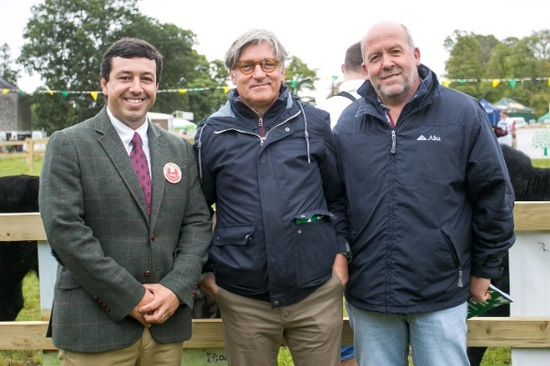
Class 35 Best Pair of animals bred by exhibitor
- Liam Walsh, Cloon, Cleggan, Co. Galway
- Michael Doorley, Cloonmurray, Strokestown, Co. Roscommon
- Alan Gibbons, Caggle, Strokestown, Co. Roscommon
- Cathal & Joe McCormack, Steil, Tulsk, Castlerea, Co. Roscommon
- Ryan & Sophie Faughnan, Lisdadnan, Mohill, Co. Leitrim

Class 36 Best Group of three
𝐉𝐨𝐚̃𝐨 𝐏𝐞𝐝𝐫𝐨 𝐌𝐞𝐝𝐚𝐥𝐡𝐚𝐬 𝐚𝐜𝐜𝐨𝐦𝐩𝐚𝐧𝐢𝐞𝐝 𝐛𝐲 𝐋𝐮𝐢𝐬 𝐏𝐚𝐮𝐥𝐢𝐧𝐨 𝐌𝐚𝐫𝐭𝐢𝐧𝐬 & 𝐋𝐮𝐢𝐬 𝐆𝐨𝐦𝐞𝐬
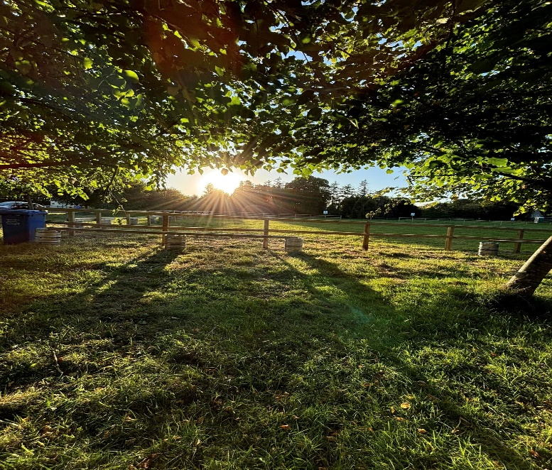
- Alan Gibbons, Caggle, Strokestown, Co. Roscommon
- Mullooly Family, Lavally, Strokestown, Co. Roscommon
- Cathal & Joe McCormack, Steil, Tulsk, Castlerea, Co. Roscommon
- Thomas Mulligan, Currycramp, Dromod, Co. Leitrim

Class 37 Traditional All-Ireland Angus X Heifer
- Emma Higgins, Ballindine, Claremorris, Co. Mayo
- Adrian Flatley, Glann, Kilkelly, Co. Mayo
- David Gibbons, Caggle, Strokestown, Co. Roscommon
- Oliver & Jason Staney, Rahard, Carnaross, Kells, Co. Meath
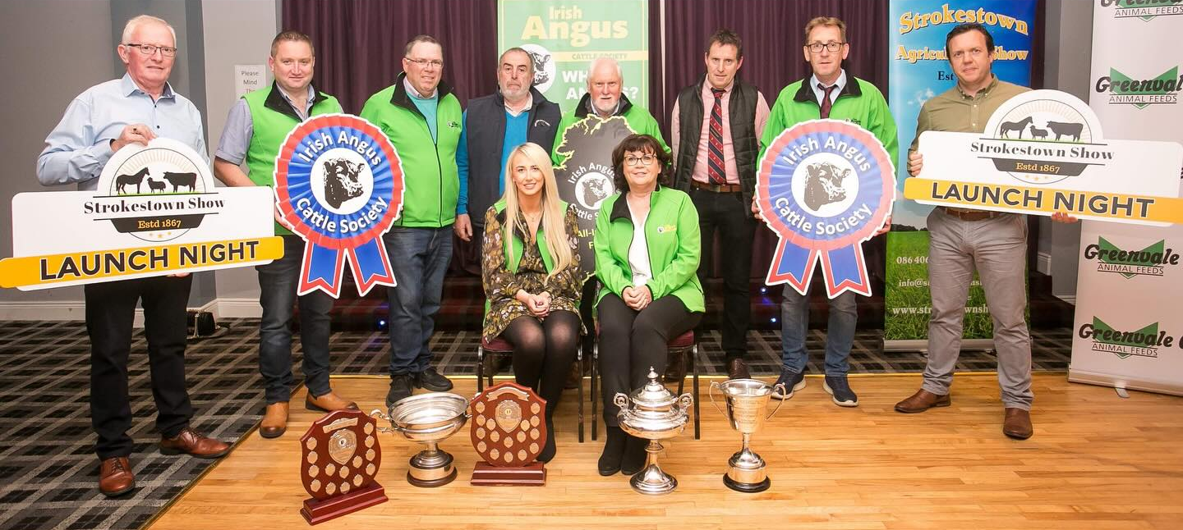
Launch of the Irish Angus Cattle Society All-Irelands John O’Beirne (Strokestown Show Chairman), Dermot Kilcrann, Oliver Flanagan, Padraig O’Connor, Kevin Diffley, John Farrell, Sean Kilkenny, Alan Dolan, Yvonne Brady, Patsy Keenan

